Name
Tutor
Course name
Date

Contents
- Introduction 1
- Theory 2
- Equipment 3
- Procedure 4
- Results 5
- Discussion 8
- Conclusion 10
- References 11

Introduction
To analyze complex circuit we can use some of Network theorems. For instance, Thevenin’s Theorem, can be used to, make a complicated circuit to a simpler one while considering the Thevenin Equivalent Resistance, a Thevenin equivalent Voltage Source, and the load. On the other hand, when using superposition the voltage at current time is taken and calculated to find the equivalent current and voltage for specific time. The aim of this experiment is to prove these network theorems.
Theory
With the superposition theorem of electrical circuits the currents or voltages at any branch of circuit might have more than one independent source that is equivalent to the algebraic sum of the currents or voltages that caused by each one of the independent source while acting alone. All of the other sources first must be "turned off" to determine the contribution of each individual source by:
- First, short circuit to make all other voltage sources independent
- Second, make an open circuit to all other current sources independent. The method is followed for every source in turn, and then all Currents or Voltages are computed to find the total currents or voltages. 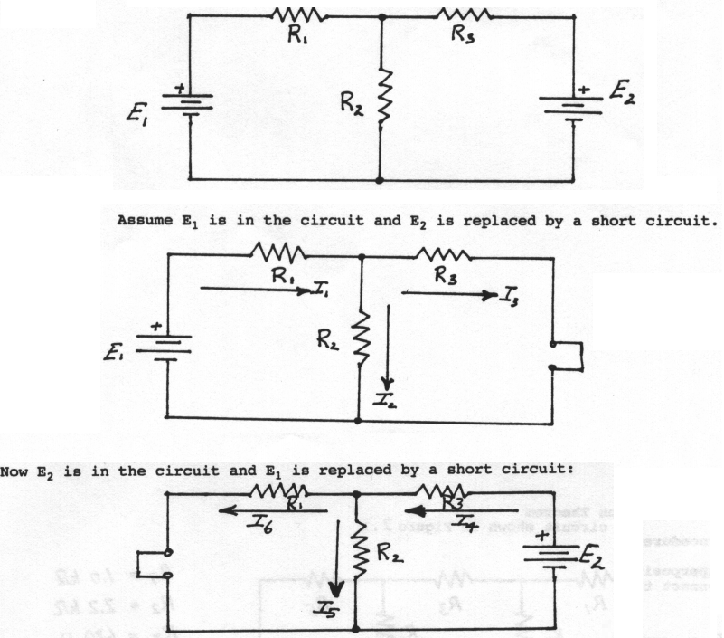
Figure 1 - Superposition
Thevenin’s theorem states that any mixing of current, voltage sources with resistor with two terminals is electrically equal to the single series resistor R_{th} and single voltage source V_{th}.
Therefore, the Thevenin voltage V_{th} can be utilized as an ideal voltage source that is equivalent to the open circuit voltage at that terminals where R_{th} can also be used as the resistance that has been measured at AB terminals with all current sources being replaced by open circuits and all voltage sources being replaced by short circuits.

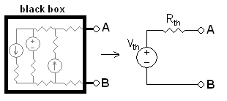
Figure 2 - Thevenin
Equipment
- DC power supplies
- DC voltmeter
- DC millimetre
- Resistors as required
- 1k ohm pot
Procedure
When using superposition, all the other independent voltage sources are replaced with a short circuit
- Commence with the left 12 V and compute the voltage and current across all resistors.
- Repeat for 5V and 12V
- To get total voltage and current add all the current and voltages.
To use Thevenin's Theorem:
- Ascertain the load and remove it. (R_{L}=R₄)
- To determine V_{th}, which the voltage avail at the load terminals when the load that been removed. (V_{AB} in Figure 3)
- Eliminate all sources, replacing all the current sources with an open circuit, all the voltage sources with a short circuit and but all internal source resistances are retained. Analyse R_{TH}, the resistance seen at the load terminals. (R_{AB} in Figure 3)
- Then create a series circuit that consists of V_{TH}, R_{TH}, and R_{L}.

VA
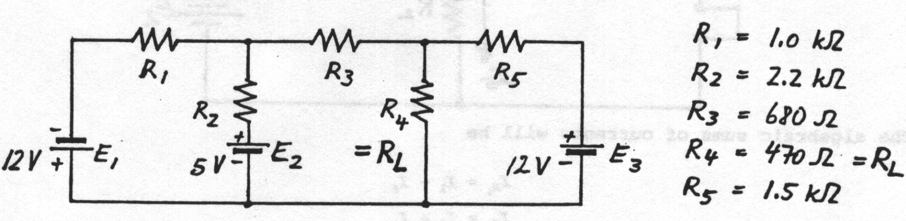
VB

Figure 3 - Circuit used in lab
Furthermore, in this lab the voltages and currents across the five resistors were measured while all the power supplies were on.

Results
Table 1 - Resistor Values
Resistors | Resistances(kΩ)
R1 | 1
R2 | 2.2
R3 | 0.68
R4 | 0.47
R5 | 1.5

Table 2 - Theoretical Results across left 12V only
Left 12V source only
Resistors | Voltage(V) | Current(mA) | Direction
R1 | -7.4 | -7.4 | right to left
R2 | -4.96 | -2.25 | bottom to top
R3 | -3.25 | -4.78 | right to left
R4 | -1.71 | -3.64 | bottom to top
R5 | -1.71 | -1.14 | right to left

Table 3 - Theoretical Results across 5V only
5V source only
Resistors | Voltage(V) | Current(mA) | Direction
R1 | -0.94 | -0.94 | right to left
R2 | -4.06 | -1.85 | bottom to top
R3 | 0.62 | 0.91 | left to right
R4 | 0.32 | 0.69 | top to bottom
R5 | 0.32 | 0.22 | left to right

Table 4 - Theoretical Results across Right 12V only
Right 12V source only
Resistors | Voltage(V) | Current(mA) | Direction
R1 | -1.14 | -1.14 | right to left
R2 | +1.14 | +0.52 | top to bottom
R3 | -1.13 | -1.66 | right to left
R4 | 2.27 | 4.83 | top to bottom
R5 | -9.73 | -6.49 | right to left
Table 5 - Total Theoretical Results by adding all 3 sources
Theoretical total current and voltages using superposition
Resistors | Voltage(V) | Current(mA) | Direction
R1 | -9.12 | -9.12 | right to left
R2 | -7.88 | -3.59 | bottom to top
R3 | -3.76 | -5.51 | right to left
R4 | 0.88 | 1.88 | top to bottom
R5 | -11.12 | -7.41 | right to left

Table 6 - Theoretical Results using mesh
Theoretical total current and voltages using mesh
Resistors | Voltage(V) | Current(mA) | Direction
R1 | -9.12 | -9.12 | right to left
R2 | -7.88 | 3.58 | bottom to top
R3 | -3.76 | -5.54 | right to left
R4 | 0.88 | 1.88 | top to bottom
R5 | -11.12 | -7.41 | right to left

Table 7 - Experimental Results using superposition
Experimental Results with one source only
Resistors | Voltage(left 12 V) | Current-mA | Voltage-5 V | Current-mA | Voltage(right 12 V) | Current-mA
R1 | -7. | -7 | -0.9 | -0.9 | -1.13 | -1.13
R2 | 4.98 | -2.26 | 4.06 | -1.85 | -1.13 | -0.51
R3 | -3.24 | -4.76 | 0.62 | 0.91 | -1.12 | -1.65
R4 | 1.74 | 3.70 | -0.32 | -0.68 | -2.25 | -4.78
R5 | 1.74 | 1.16 | -0.32 | -0.21 | 9.75 | 6.5

Table 8 - Experimental Results with all 3 sources together
Experimental Results with all power sources
Resistors | Total voltage(V) | Total current(mA)
R1 | -9.09 | -9.09
R2 | 7.9 | 3.59
R3 | -3.75 | -5.51
R4 | -0.85 | -1.81
R5 | 11.15 | 7.43

Table 9 - Experimental and Theoretical Thevenin equivalence values
 | V_{th}(V) | R_{th}(kΩ)
Theoretical Results | 2.56 | 0.715
Experimental Results | -2.15 | 0.711

In the experimental results the negative signs in the voltages and currents do not state anything about the flow direction since we are required to estimate our theoretical values to establish the direction of current.

Discussion
Table 10 - Theoretical vs. Experimental all sources
Theoretical vs. Experimental with all 3 sources together
 | Theoretical results |  | Experimental results |  | Difference in Voltage (%) | Difference in Current (%)
 | Voltage(V) | Current(mA) | Voltage(V) | Current(mA) | Difference in Voltage (%) | Difference in Current (%)
R1 | -9.12 | -9.12 | -9.09 | -9.09 | 0.99 | 0.99
R2 | -7.88 | 3.58 | 7.9 | 3.59 | 0.51 | 0.27
R3 | -3.76 | -5.54 | -3.75 | -5.51 | 0.28 | 0.26
R4 | 0.88 | 1.88 | -0.85 | -1.81 | 0.00 | 1.08
R5 | -11.12 | -7.41 | 11.15 | 7.43 | 0.00 | 2.20
Table 11 - Theoretical vs. Experimental superposition
Theoretical vs. Experimental with superposition
 | Theoretical results |  | Experimental results |  | Difference in Voltage (%) | Difference in Current (%)
 | Voltage(V) | Current(mA) | Voltage(V) | Current(mA) | Difference in Voltage (%) | Difference in Current (%)
R1 | 9.09 | 9.09 | 9.18 | 9.18 | 0.99 | 0.99
R2 | 7.9 | 3.61 | 7.94 | 3.61 | 0.51 | 0.27
R3 | 3.79 | 5.57 | 3.78 | 5.56 | 0.28 | 0.26
R4 | 0.88 | 1.85 | 0.88 | 1.87 | 0.00 | 1.08
R5 | 11.36 | 7.75 | 11.36 | 7.57 | 0.00 | 2.20

Table 12 - Theoretical vs. Experimental Thevenin equivalence circuit
Theoretical vs. Experimental for Thevenin equivalence circuit
 | Vth(V) | Rth(kΩ) | Difference in Voltage (%) | Difference in Current (%)
Theoretical Results | 2.56 | 0.715 | 0.19 | 1.34
Experimental Results | -2.15 | 0.711 | 0.19 | 1.34
In all these results difference in voltage=% error calculated by
$$\% error=\left|\frac{Experimental-Theoretical }{Theoretical }\right|*100$$
Using the results obtained in table 12 we discover that the voltage across R4 was measured the experimental value is 0.878V and the theoretical value was 0.872V where we can say from those values that they are almost similar. As revealed in tables above values are fairly accurate because the differences are less than 2.5%. The resistance of wires in the experiment may have changed the actual current. Where the load can be altered, Thevenin's is used.
Thus, to reduce a circuit that is complex to a simple circuit with 1 resistor (R_{TH}) and with 1 source (V_{Th}) series. We can measure any resistor by placing any kind of load and the variations of voltages and current across the load measured. The load can be a bulb, fan, etc. thus anyone can find a suitable component to use. Besides, where maximum power is needed from source, Thevenin is utilized where R_{TH}=R_{L.}

On the other hand, Thevenin's theorem is valid only for bilateral and linear networks. Basically, linearity of any circuit is over a certain range hence it is only valid for certain range. On the other hand, the advantage superposition is that the circuit can be determined with at least one power source at a time. It will enable to simplify the circuit making the analysis easier therefore, means lesser equations to solve.
Conclusion
The experimental values were counterchecked with the theoretical results and were found that they have a Difference % or maximum Error % = 2.30 %.All the results were very close showing that both the apparatus and the human error were kept to the minimum. Thevenin's Theorem is useful in terms of determining power systems and other circuits. Where in the circuit one particular resistor known as the “load” resistor which is subject to change and re-calculation of the circuit is essential for each trial, to establish current through it and voltage across it.
More so, Thevenin’s theorem is significantly applied in measurement of resistance using the Wheatstone bridge. Hence using Kirchhoff's voltage and current laws, the superposition theorem has been verified. Moreover, under Thevenin’s theorem the current flowing through a load resistance is similar to the current that flows through it under normal condition.
Consequently, from all the results above it showed that using any methods there is no difference because in the end one will get the same answer. Nevertheless, for example, if there was some difference it will as a result of zero reading or something else.

